1.Check If All 1's Are at Least Length K Places Away

Given an binary array nums and an integer k, return true if all 1's are at least k places away from each other, otherwise return false.

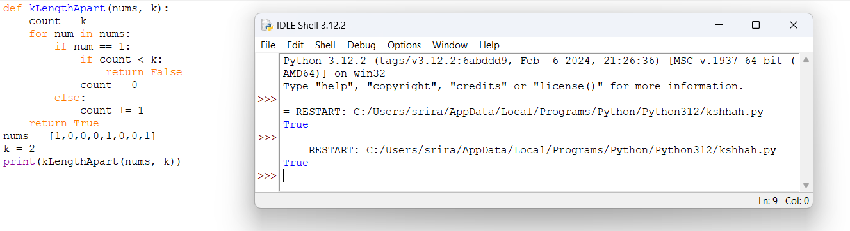

2. Longest Continuous Subarray With Absolute Diff Less Than or Equal to Limit

Given an array of integers nums and an integer limit, return the size of the longest non-empty subarray such that the absolute difference between any two elements of this subarray is less than or equal to limit.

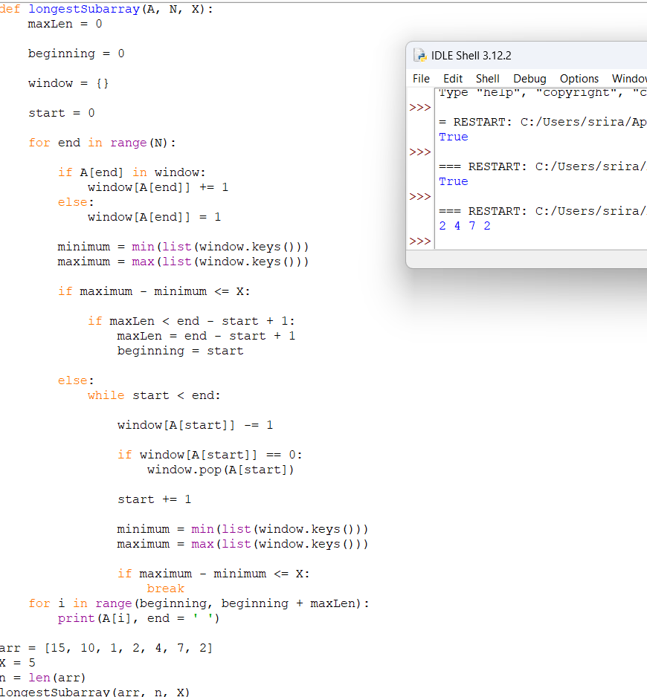

3. Find the Kth Smallest Sum of a Matrix With Sorted Rows

You are given an m x n matrix mat that has its rows sorted in non-decreasing order and an integer k.

You are allowed to choose exactly one element from each row to form an array.

Return the kth smallest array sum among all possible arrays.

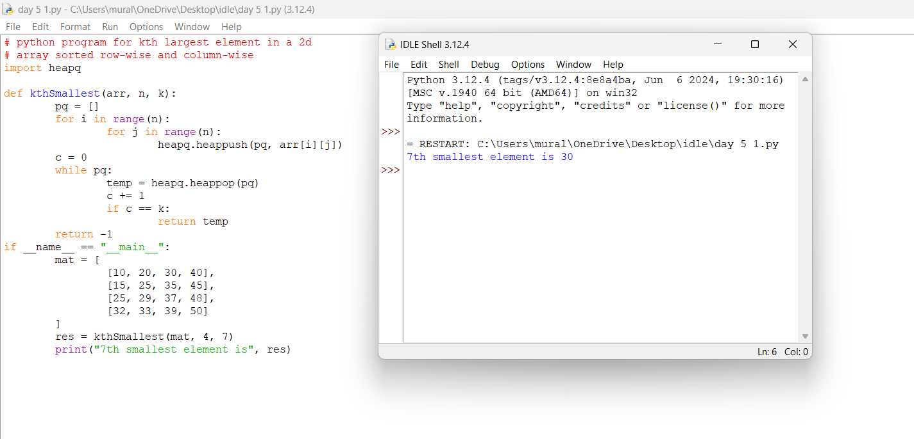

4. Evaluate Boolean Expression

SQL Schema

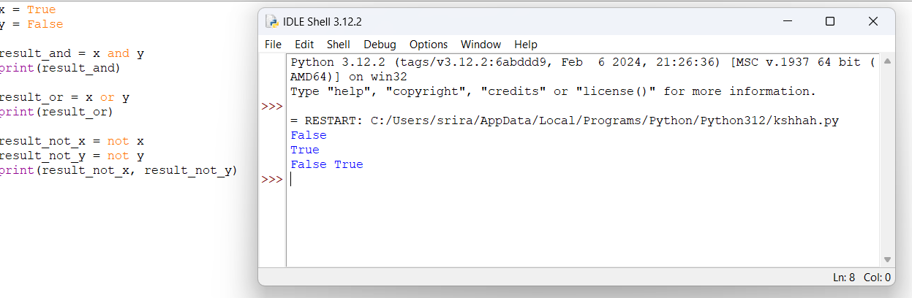

5. Build an Array With Stack Operations

You are given an integer array target and an integer n.

You have an empty stack with the two following operations:

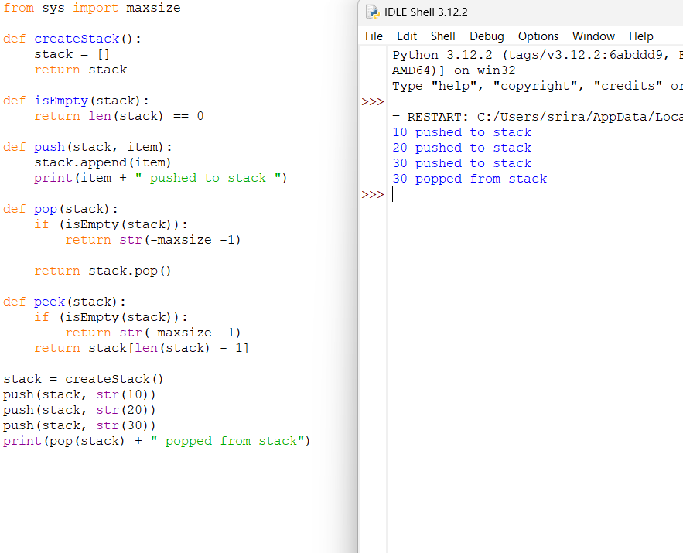

6. Count Triplets That Can Form Two Arrays of Equal XOR

Given an array of integers arr.

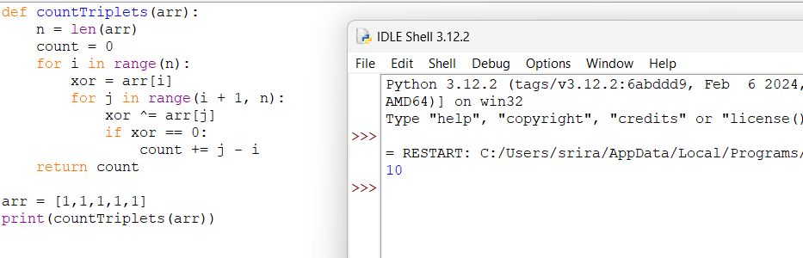

We want to select three indices i, j and k where (0 <= i < j <= k < arr.length).

7. Minimum Time to Collect All Apples in a Tree

Given an undirected tree consisting of n vertices numbered from 0 to n-1, which has some apples in their vertices. You spend 1 second to walk over one edge of the tree. Return the minimum time in seconds you have to spend to collect all apples in the tree, starting at vertex 0 and coming back to this vertex.

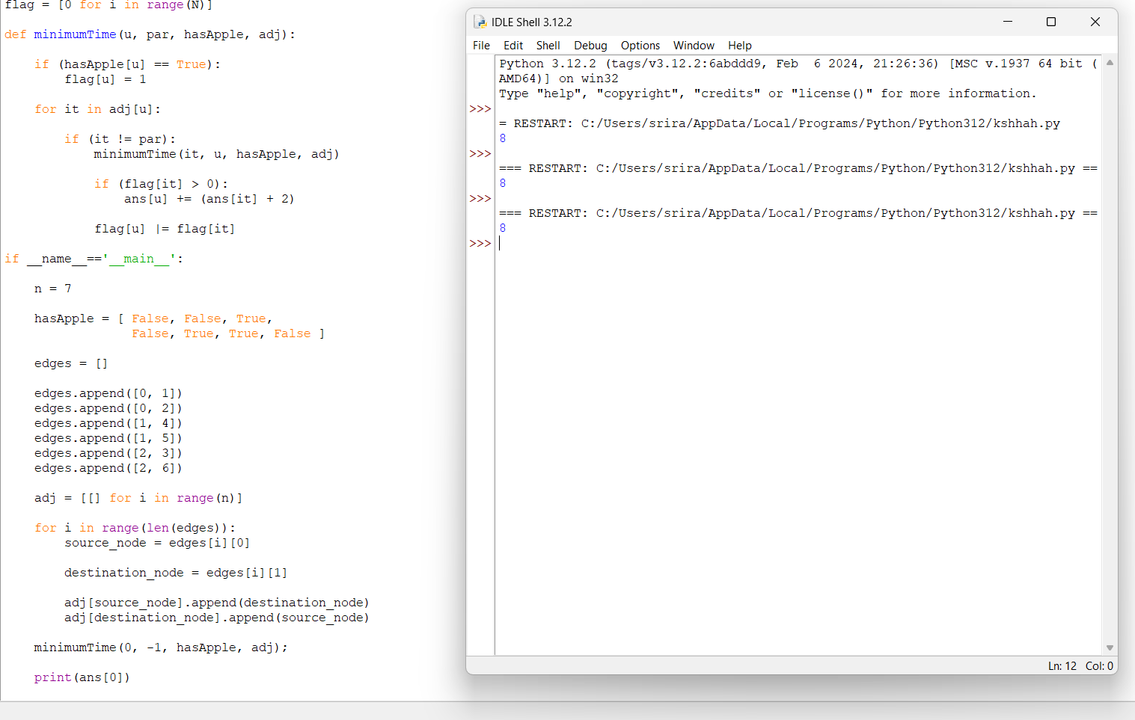

8. Number of Ways of Cutting a Pizza

Given a rectangular pizza represented as a rows x cols matrix containing the following characters: 'A' (an apple) and '.' (empty cell) and given the integer k. You have to cut the pizza into k pieces using k-1 cuts.

